CMPEN 275 Lab 1

September 9, 2019

Jefferson Bui

**Objectives:**

In this lab our main goal is to learn about the operations and features of a breadboard for prototyping electronic circuits. Then we will discuss and implement a voltage regulator to provide power to an LED circuit on the breadboard.

**Materials:**

1. Breadboard

2. (1) LED

3. 5-volt voltage regulator (7805)

4. 9-volt battery or power supply

5. 330 ohm to 1K ohm resistor

6. DMM (Digital Multi-meter)

7. SPST switch

8. Function generator

9. Oscilloscope

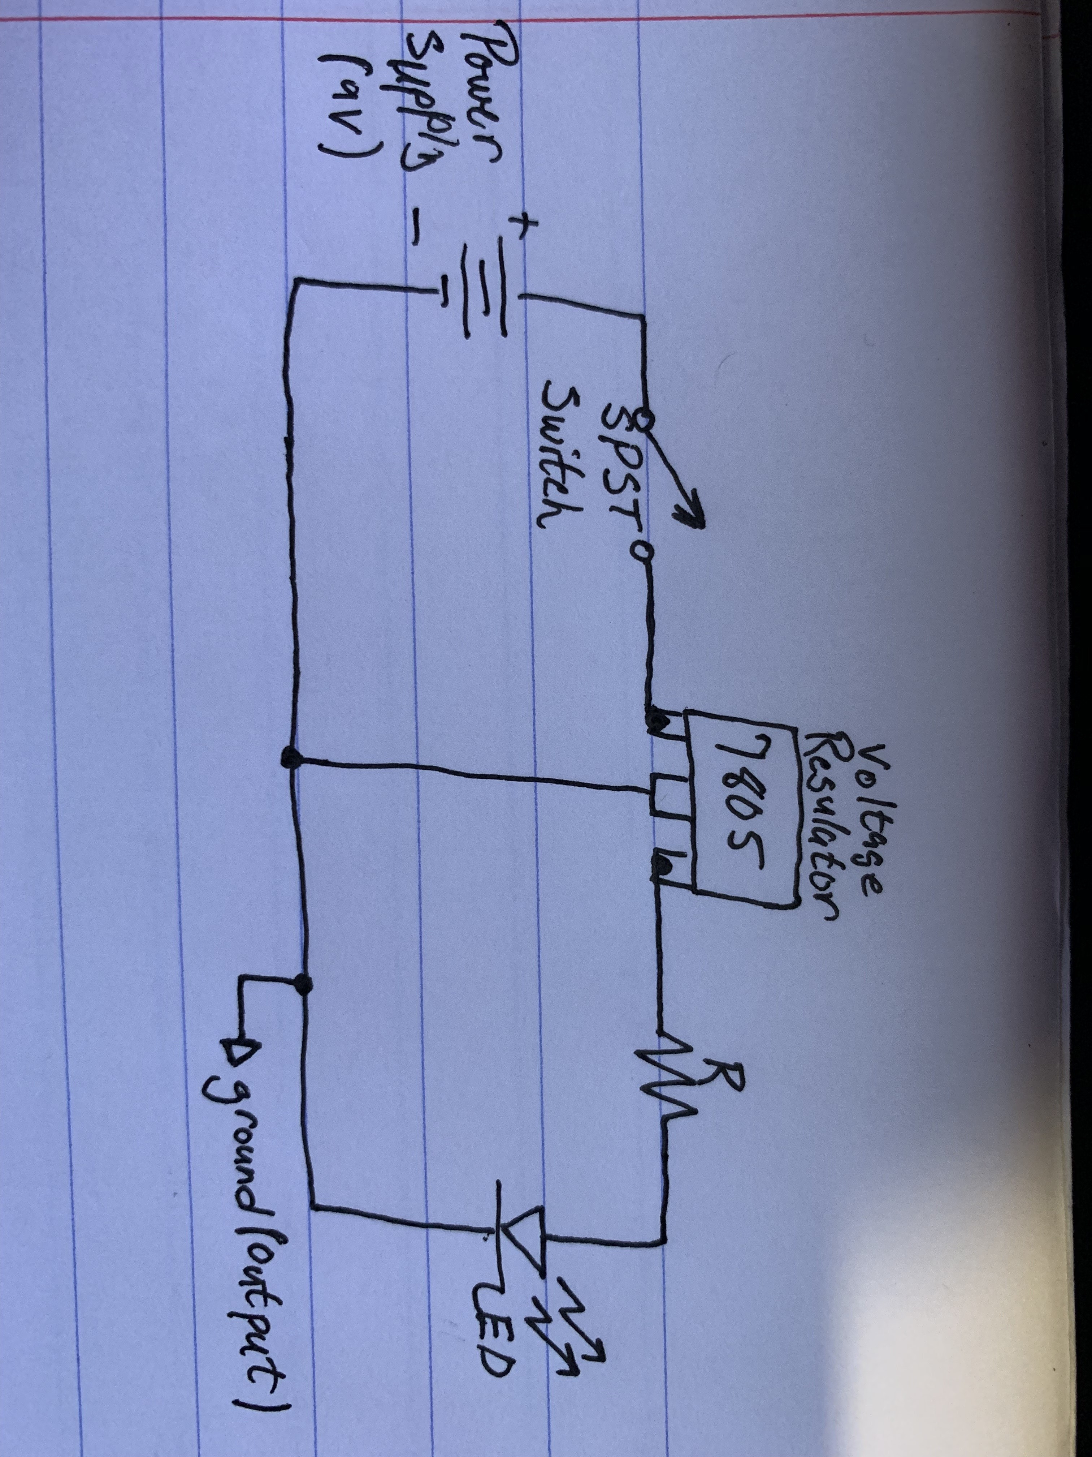

**Results:**

Initial Recorded Values:

Battery (Voltage Source): 9V

7805 Regulator: 5.06V

Across R: 3.1V

Across LED: 1.8V

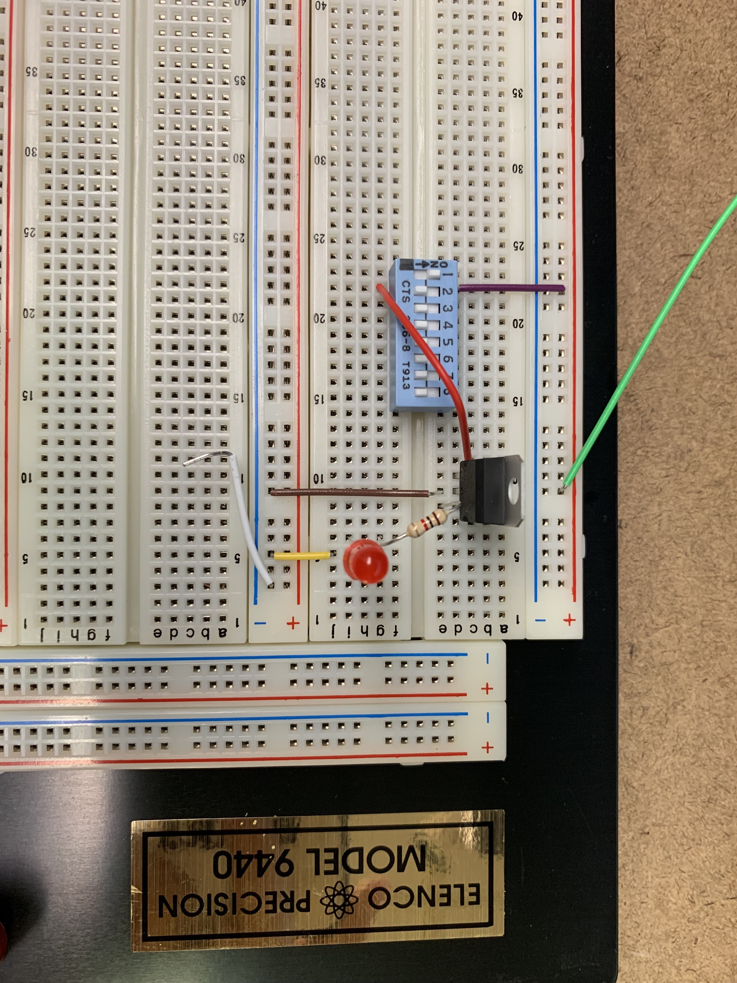

Vpp at 3V:

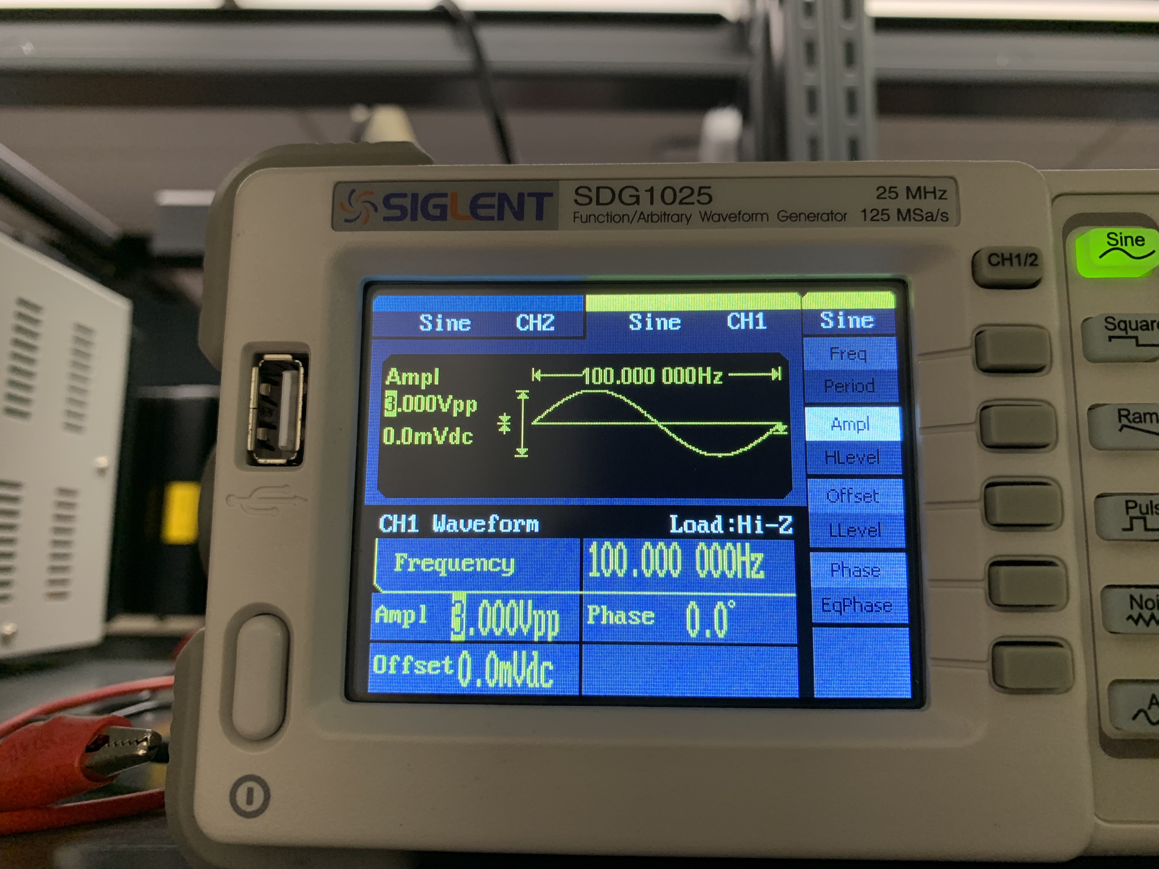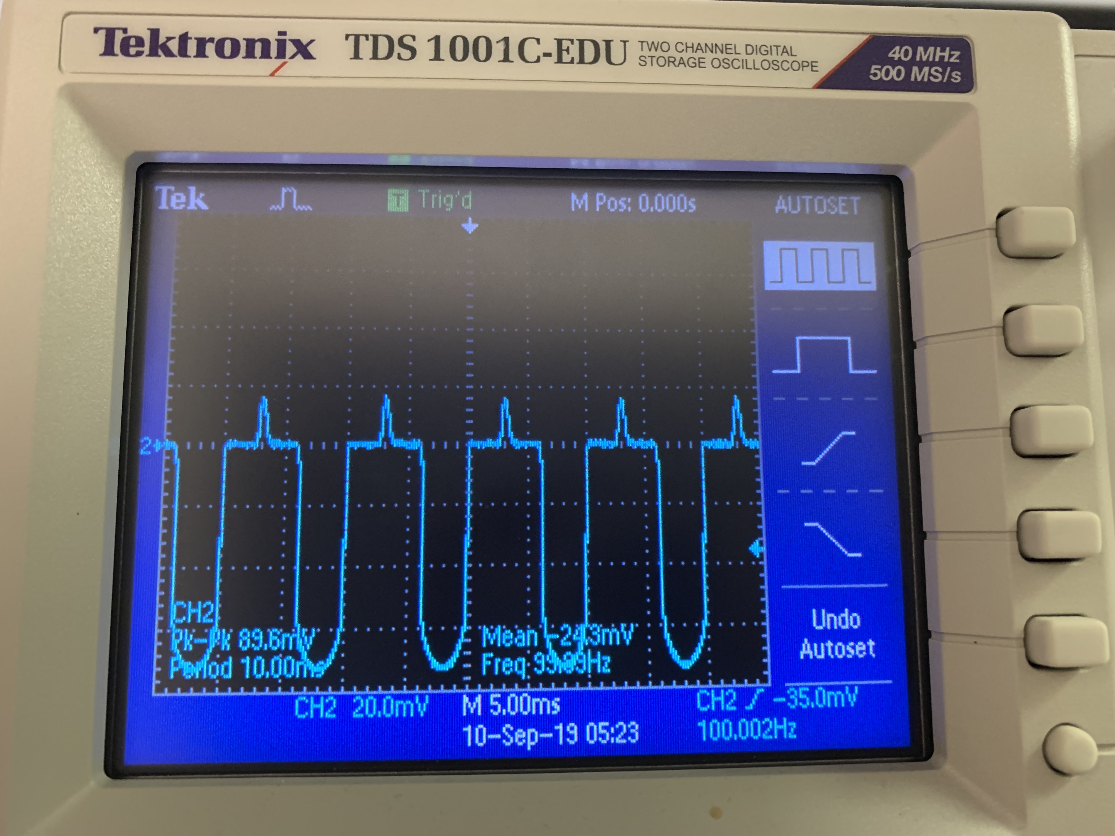

Vpp at 5V:

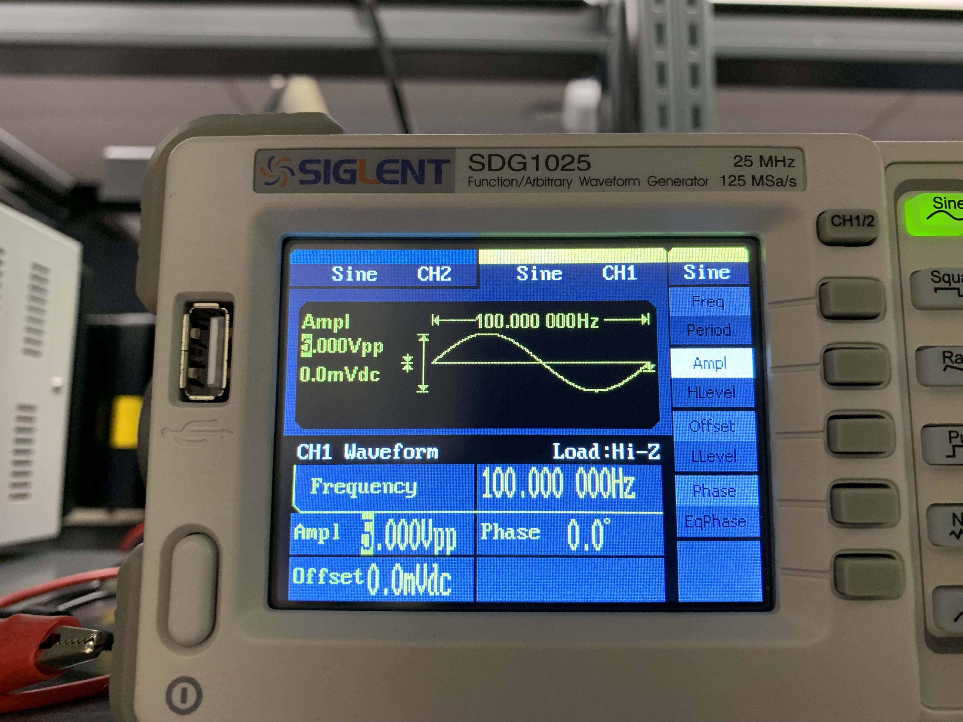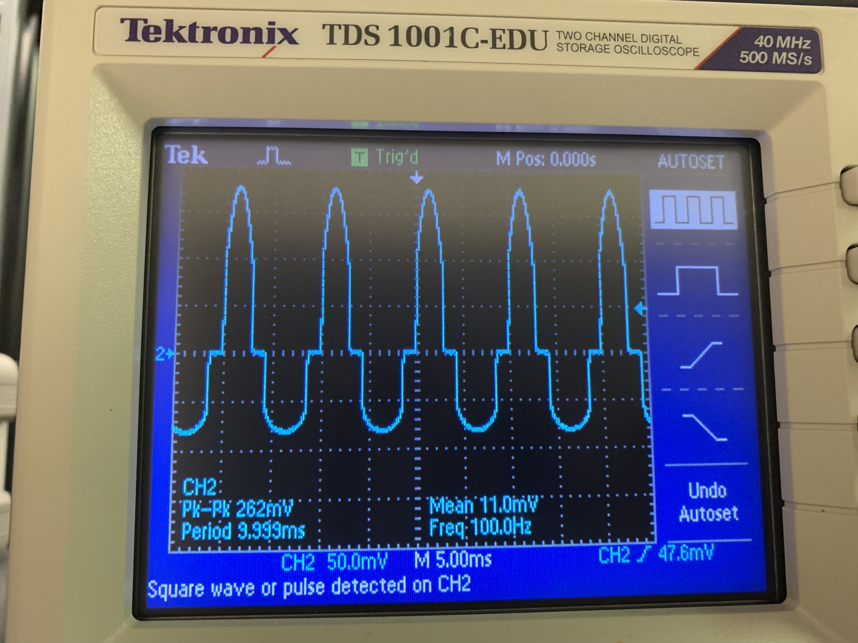

Vpp at 9V:

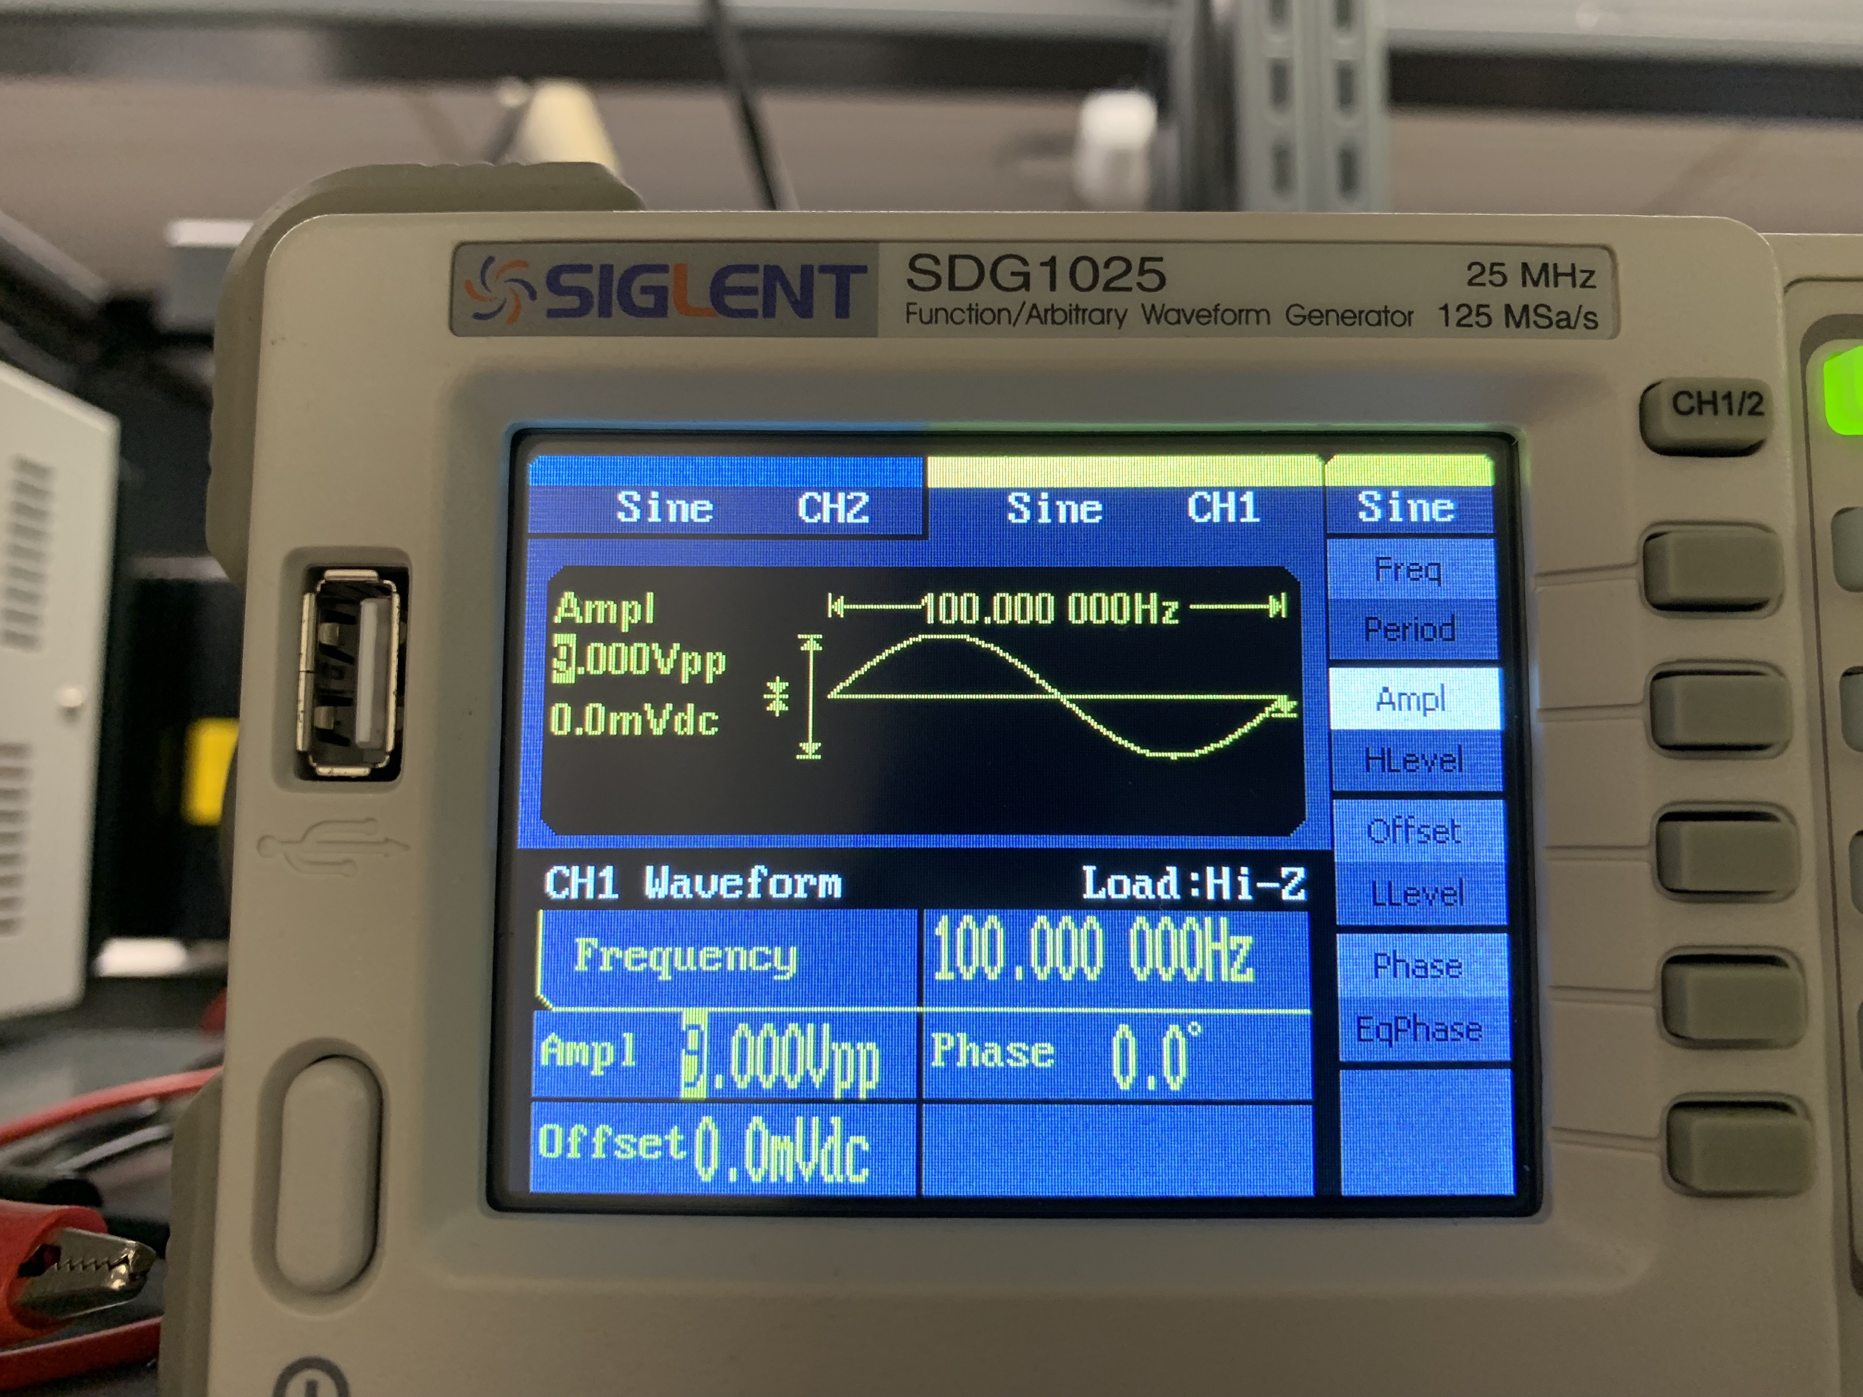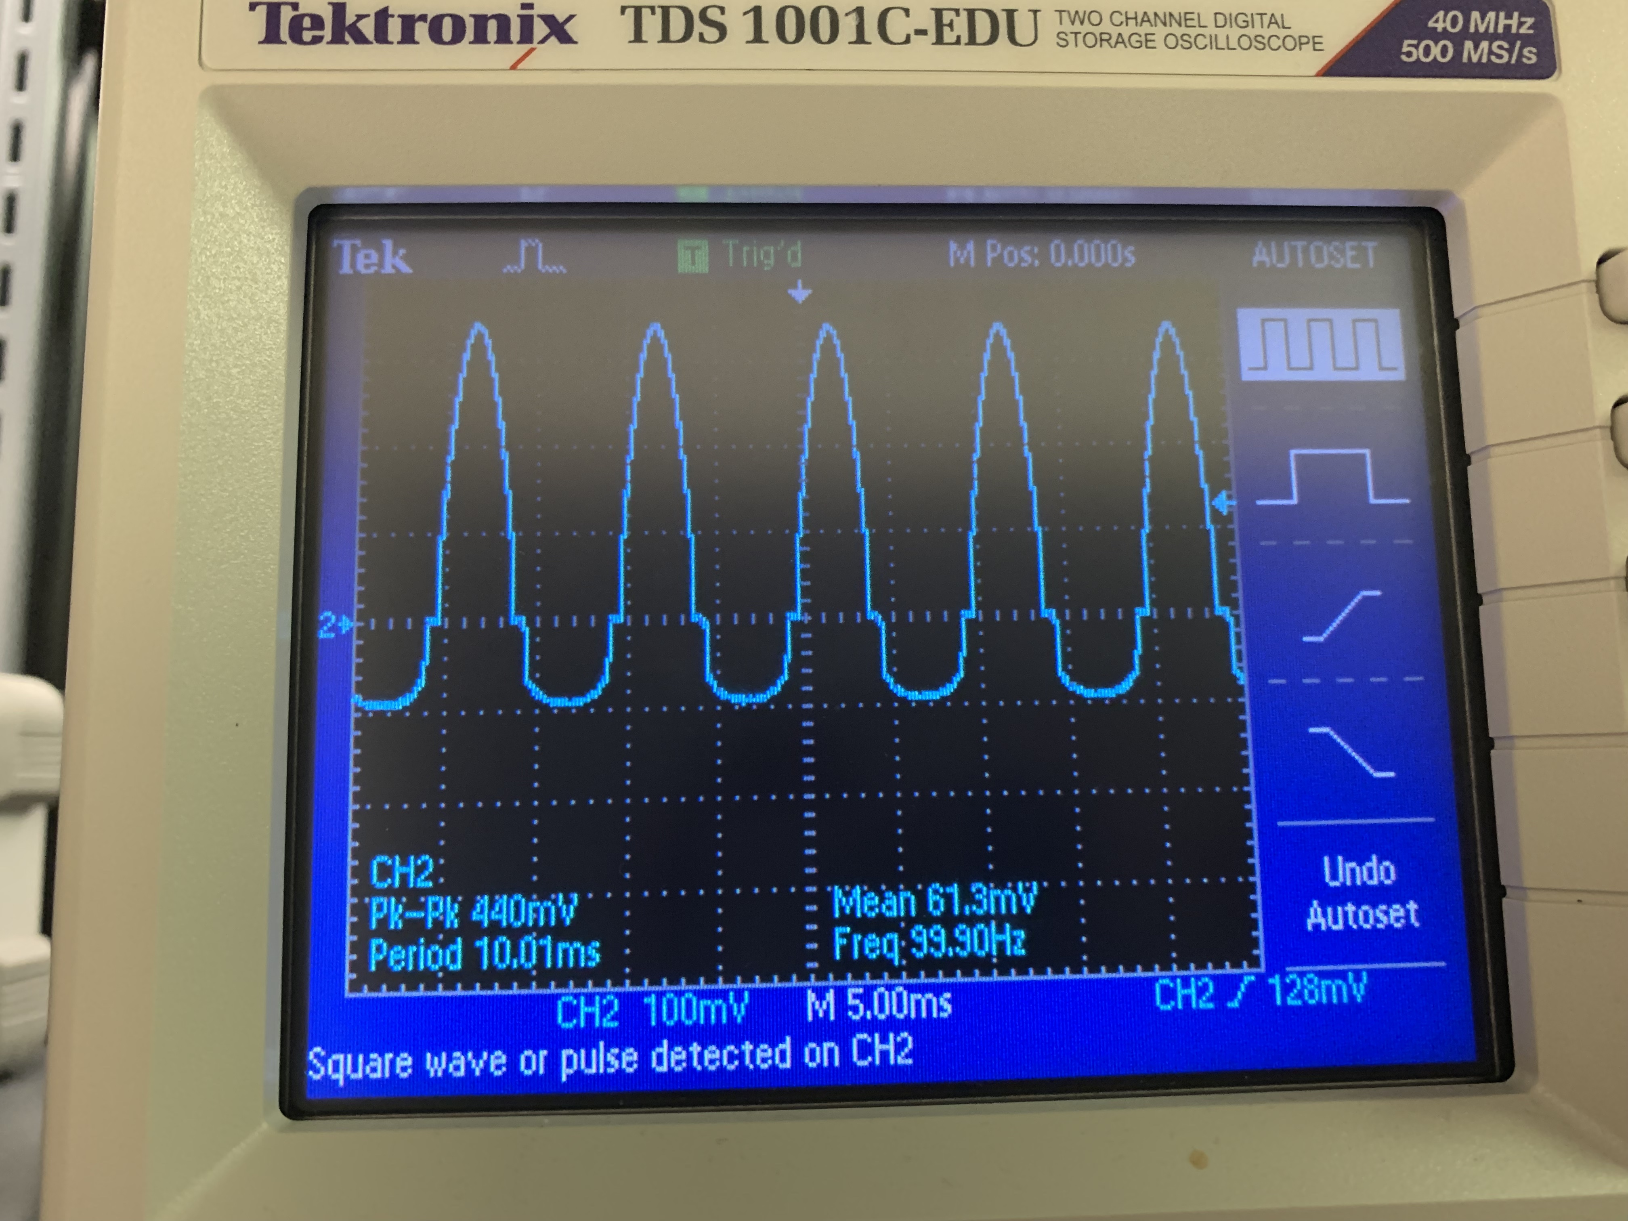

The differences occur due to the change in voltage from 3 to 5 to 9. The increase in voltage makes each of the peaks go higher.

**Questions:**

1. What is the purpose of a voltage regulator?

The purpose of a voltage regulator is to maintain the voltage in a circuit at a desired value. The regulators ensure that certain components don’t receive too much voltage that would otherwise damage that component.

2. What is the purpose of the electrolytic capacitors in the voltage regulator circuit?

The purpose of the electrolytic capacitors in the voltage regulator circuit is to store the voltage.

3. What is the current specification for your LED (see package)? What does the

current value mean?

The current specification, listed as forward current, for the LED is 30mA. This current value the max the LED will be able to take is 30mA before it burns out.

4. What is the predicted current through your LED based on the voltage and series

resistor? Show calculation.

According to Ohm’s Law, which is V(Voltage) = I(Current)*R(Resistor). In this case, we are finding the current that would run through the LED. Re-write the equation as I = V/R and plug in the voltage and resistor. I = 5V/1000Ω. I will then equal 0.005A and convert that to 5mA. 5mA is the predicted current.

5. Are LEDs polarized? What happens when you reverse the polarity of the LED in

your circuit?

LEDs are polarized. If you were to reverse the polarity of the LED in the circuit, it would result in the LED not lighting up.

6. Are resistors polarized? What happens when you reverse the polarity of the resistor in your circuit?

Resistors are not polarized. Reversing the polarity will still give the same results as if it was not reversed.

7. Should the resistor R in series with the LED be placed before the LED (toward the + voltage) or after the LED (toward the – voltage)? Include in your notebook a drawing for each configuration.

It does not matter where resistor goes in this circuit. It can go before the LED or after the LED. As long as there is that resistor in the circuit, it will be fine either way.

8. Are capacitors polarized?

Yes, they are polarized.

9. What is wrong with the following breadboard circuit? Explain. What is the voltage across the resistor? What is current through the resistor?

The resistor’s two ends are plugged into the same strip as the 5V source instead of having one end of the resistor connecting to line connected from the 5V and the other end of the resistor into one with no power running through it to output the 3V its should normally pass.